**DAILY ONLINE ACTIVITIES SUMMARY**

|  |  |  |  |  |  |  |  |  |
| --- | --- | --- | --- | --- | --- | --- | --- | --- |
| **Date:** | **26-05-2020** | | | | | **Name:** | **Sinchana** | |
| **Sem & Sec** | **6 B** | | | | | **USN:** | **4AL17CS117** | |
| **Online Test Summary** | | | | | | | | |
| **Subject** | | **CGV** | | | | | | |
| **Max. Marks** | | **30** | | **Score** | | | **20** | |
| **Certification Course Summary** | | | | | | | | |
| **Course** | **The complete cyber security course** | | | | | | | |
| **Certificate Provider** | | | **Udemy** | | **Duration** | | | **12.0 hours** |
| **Coding Challenges** | | | | | | | | |
| **Problem Statement: 1. count digits 2.** **not divisible by 2 and 3 3.** **Palindrome 4.permutation 5.series 6.sub arrays** | | | | | | | | |
| **Status: Success** | | | | | | | | |
| **Uploaded the report in Github** | | | | | **Yes** | | | |
| **If yes Repository name** | | | | | **coding** | | | |
| **Uploaded the report in slack** | | | | | **Yes** | | | |

Online Test Details: (Attach the snapshot and briefly write the report for the same)

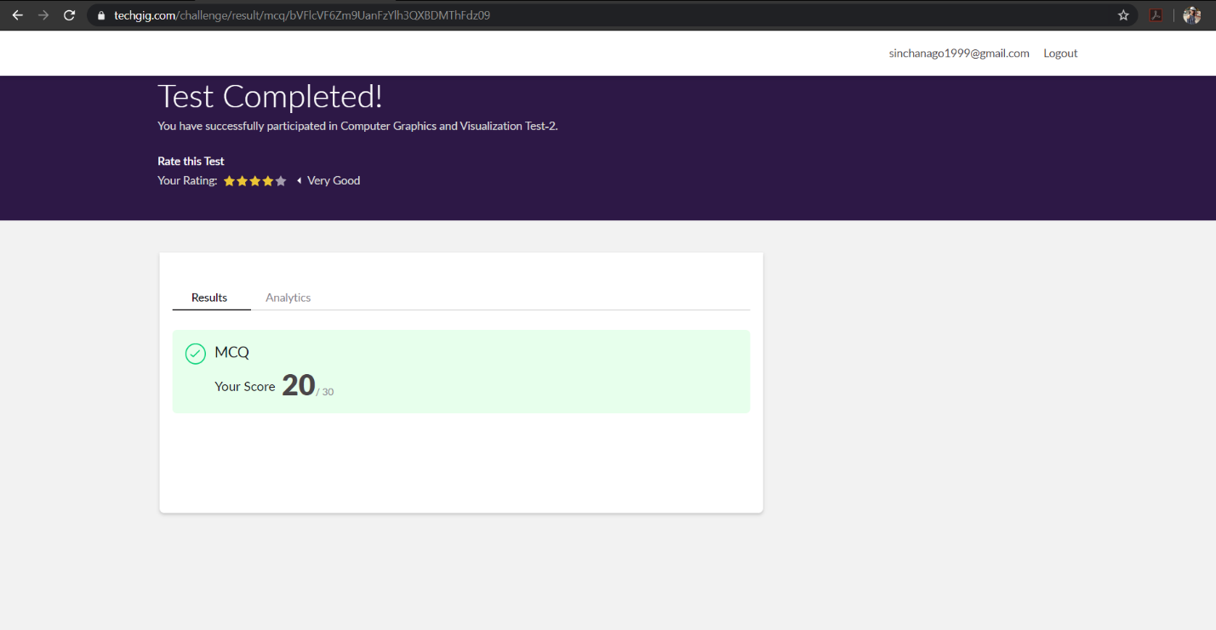

The test was held between 9:30 am to 10:00 am. It consisted of only 1 round and the total marks assigned was 30.The above snapshot is the output of my 1st IA test.

Certification Course Details: (Attach the snapshot and briefly write the report for the same)

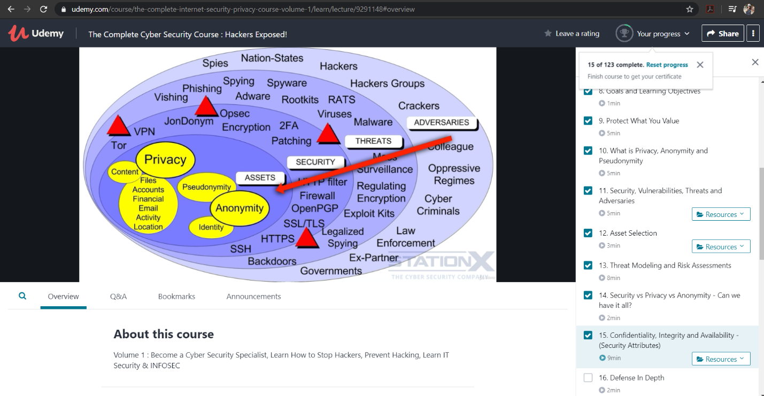

Online Certification Course Summary: Today I have learnt about security assessment and test strategies and description about log management. Even learnt about different testing techniques and security testing in the Software Development Life Cycle and internal and third-party audits

Coding Challenges Details: (Attach the snapshot and briefly write the report for the same)

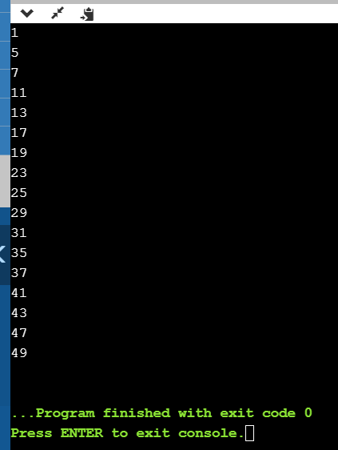

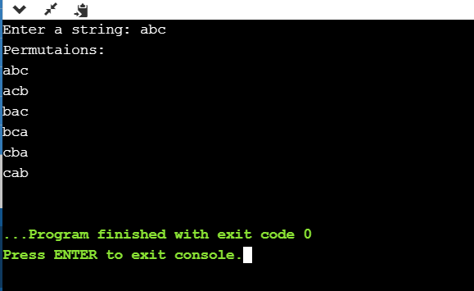

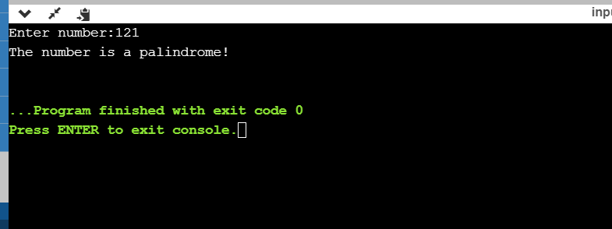

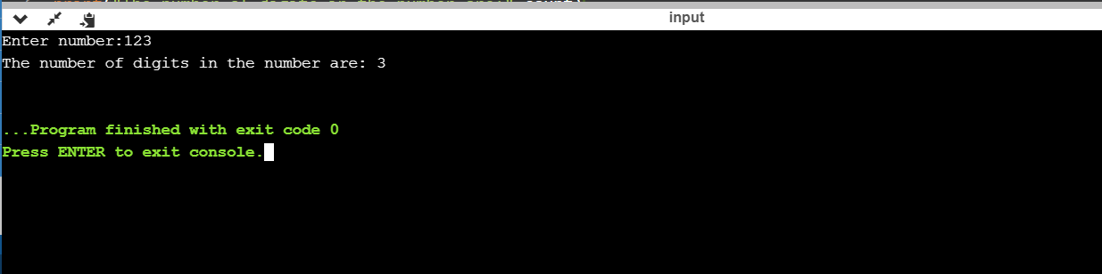

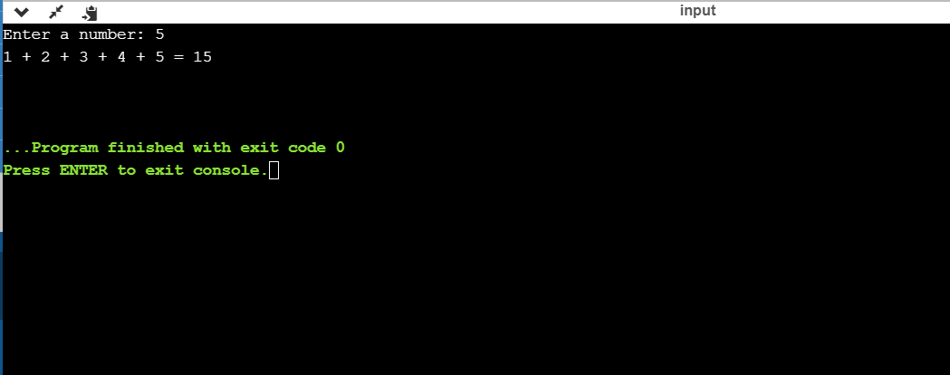

Link in GitHub : <https://github.com/sinchana514/coding>

<https://github.com/sinchana514/coding/tree/master/26%20th%20may>